ADMINISTRATIVE SUPPORT PERSONNEL GUIDELINES

BRECKSVILLE-BROADVIEW HEIGHTS

CITY SCHOOL DISTRICT

Effective:

August 1, 2016 2019

through

July 31, 2018 2021

ADMINISTRATIVE SUPPORT PERSONNEL GUIDELINES

These administrative support personnel guidelines replace and/or supersede all previous rules, administrative support guidelines and procedures that pertain to administrative support personnel in the Brecksville-Broadview Heights City School District. Any exceptions to these rules shall be noted in individual contracts.

I. Administrative Support Personnel
The following personnel are exempt from the bargaining unit.

A. Enumeration of Positions Covered

Administrative Assistant to the Director of
Business Services 260 days
Administrative Assistant to the Director of
Curriculum and Instruction 260 days
Administrative Assistant to the Director of
Human Resources 260 days
Administrative Assistant to the Director of
Pupil Services 260 days
Assistant to the Superintendent 260 days
Assistant to the Treasurer(s) 260 days
CAPA Coordinator TBD days
CAPA Prevention Specialists 196 days
CAPA Project Secretary 196 days
Child Care Coordinator (BeeKeepers Program) 260 days
EMIS Coordinator 260 days
Fiscal Assistant(s) 260 days
Health Care Coordinator(s) 186 days
Network Specialist 260 days

Any of the above employees working less than 260 days are not paid for
holidays and have no paid vacations.

B. Salary Provisions

- Effective July 1, 2012, employees will be paid at the rates shown on the following schedule at their step placement for the 2012-2013 contract year.

- For the 2013-2014 and 2014-2015 contract years, employees will be paid at the rates shown on the following schedule and step advancement for service is frozen at the applicable step held in the 2012-2013 contract year, and shall not be made up in the future.

- At the Board’s option, to be exercised not later than June 15, 2015, the Board may extend the term of the Agreement an additional year, until June 30, 2016. In such event employees will be paid for the additional year at the rates shown on the following schedule and step advancement is frozen at the applicable step held in the 2012-2013 contract year, and shall not be made up in the future.

- Step advancement will resume upon the expiration of the term of the 2012-2016 Agreement.

- Effective August 1, 2016, employees will receive a one and one-half percent (1-1/2%) across-the-board increase or the percentage increase in the teacher base salary for the 2016-2017 school year, whichever is greater.

- For the 2017-2018, school year, 2019-2020 contract year, employees will receive a one and one-half percent (1-1/2%) _two percent (2%)_ across-the-board increase or the percentage increase in the teacher base salary for the 2017-2018 2019-2020 school year, whichever is greater.

- At the Board’s option, and consistent with the terms and conditions of the BEA settlement, to be exercised not later than June 15, 2018, the Board may extend the term of the Agreement additional years. In such event employees will receive an across-the-board increase of one and one-half percent (1-1/2%) or the same as the percentage increase for the teacher base salary for the additional school years, whichever is higher.

- All steps frozen in the past will not be restored.

- All wage increases shall be retroactive to August 1 of the year the increase is applicable.

- In addition, all full-time members of the unit will receive a one-time educational stipend of Five Hundred Dollars ($500.00) to be paid within thirty (30) days after the ratification of this agreement by both parties. The bonus for part-time employees will be prorated but no unit member will receive less than Two Hundred Dollars ($200.00).

- Salary anniversary date to be August 1.

- Annual increase based on the administrative support compensation schedule is included in these guidelines.

- Computation of a day's salary when this determination is necessary (deduct day, additional workday, severance pay, payment for accrued, unused vacation days, prorating salary or benefits in the event the administrative support employee leaves employ during the term of contract, etc.) will be done in the following manner for 12-month personnel:

    - Total Contract Days 260

    - Less Holidays 12

    - (New Year's Day + one day, Martin Luther King Day, Presidents' Day, Good Friday, Memorial Day, July 4th, Labor Day, Thanksgiving + one day, Christmas + one day)

    - Less Vacation Days

    - Balance divided into Total Annual Salary

    - Employees who work more than 260 contract days in a fiscal year are given an additional day(s) off to compensate for this, upon notification to immediate supervisor.

C. New Employment

Upon hire, an external applicant hired under the Administrative Support Personnel Guidelines may be allowed credit up to 5 years for job-related experience as determined by the employee’s supervisor. Evaluation and approval of this credit shall be made by the Superintendent/designee. The Superintendent/designee shall notify the Treasurer’s Office of any credit for job-related experience.

An internal applicant hired under the Administrative Support Personnel Guidelines will have his/her wage adjusted to the appropriate step as indicated on the Administrative Support Personnel Salary Schedule (e.g., Step 5 – BOSS is calculated as Step 4 of these guidelines).

D. Ohio Deferred Compensation Plan

Administrative support personnel may contribute to the Ohio Deferred Compensation Plan (an Internal Revenue Code Section 457 Plan) via payroll deductions.

E. Section 125 Plan (“Cafeteria Plan”)

1. The Board established a “Cafeteria Plan.”

2. The Cafeteria Plan will be designed to meet the requirements of Internal Revenue Code (“IRC”) Section 125 and applicable regulations. Accordingly, each employee will have an opportunity on an annual basis to enroll in the Cafeteria Plan. The election to participate must be submitted on or before September 15th of each school year and may not be revoked during the current plan year (October 1st through September 30th) unless there is a change in the employee’s circumstances that, in accordance with IRC Section 125, permits the employee to change his/her election under the plan (e.g., divorce, death of spouse, change in employment status including employment status affecting a spouse or dependent, birth or adoption of a child, a child losing eligibility for coverage, a court order requiring coverage, or other enrollment rights consistent with federal law). If revoked, any account balance will be governed by paragraph 5 below. Details of the Cafeteria Plan will be provided on an annual basis at the time of enrollment and will also be available through the Board Treasurer’s office.

3. Dependent Care FSA

a. Under the Cafeteria Plan, each employee will be allowed to make a pre-tax “salary reduction” election up to the maximum amount allowable under IRC Section 129 (currently $5000 per year), and receive a corresponding credit under a dependent care FSA. Under the dependent care FSA, reimbursement may be received for dependent care expenses described in IRC Section 129.

b. The salary reduction and corresponding credits will be made and issued in eighteen (18) equal installments, beginning with the last pay in October.

c. No employee may be entitled to reimbursement from the dependent care account in excess of the amount credited to the account.

4. Health Care FSA

a. Under the Cafeteria Plan, each employee will be allowed to make a separate pre-tax “salary reduction” election up to a maximum amount of $4,000 per year, and receive a corresponding credit under a health care FSA. Under the health care FSA, reimbursement may be received for medical expenses (under IRC Section 213) that are not otherwise reimbursable by the health care plans of the Board or of another employer.

b. The salary reduction shall be made in eighteen (18) equal installments beginning with the last pay in October.

5. Forfeiture of Unused Allocations

To comply with the requirement of IRC Section 125, amounts remaining in either the dependent care or health care FSA at the end of each plan year will be forfeited. In the event a employee separates from employment during a plan year with a remaining balance in the FSA account(s), the employee may continue to receive reimbursements from the account(s) through the end of that plan year.

6. Recovery of Health Care FSA Reimbursements in Excess of Credits

In the event an employee’s reimbursement under a health care FSA cannot be offset by a corresponding credit due to separation from employment or an unpaid leave, the Board may withhold the value of the outstanding credit from the employee’s remaining paycheck(s).

7. Plan Administrator

The Board shall be the administrator of the Cafeteria Plan, but may delegate administration to the Board Treasurer’s office and/or a third party administrator. Any administrative costs associated with a third party administrator will be offset by a service fee of $1 per pay per participating member.

F. Board-Paid Fringe Benefits

- Life Insurance (including Accidental Death and Dismemberment) -- Two times annual salary (or as noted in individual contracts).

- Hospitalization and Medical

Effective November 1, 2012, Each Administrative Support employee enrolled in the District hospital and medical plan shall have on a monthly basis, 15% of the monthly insurance premium deducted from his/her paychecks (using the Section 125 Plan), an increase of 5%. Alternately Administrative Support employees may opt to participate in the “IDEAL” plan during the open enrollment period. The Board will pay 100% of the health and prescription drug premium costs for any Administrative Support employee participating in the “IDEAL” plan (See attached “IDEAL” plan document).

NOTE: The parties agree to add a Minimum Value Insurance Plan to the Agreement to comply with the Affordable Health Care Plan requirements (ACA).

- Dental Plan and Prescription Drug Plan

Effective November 1, 2012, Each Administrative Support employee enrolled in the District dental and prescription drug plan shall have, on a monthly basis, 15% of the monthly insurance premium deducted from his/her paychecks (using the Section 125 Plan), an increase of 5%.

- Spousal Enrollment

Effective November 1, 2012, If an employee’s spouse is eligible to participate, as a current employee or retiree in group health insurance and/or prescription drug insurance sponsored by his/her employer or any public retirement plan, the spouse must enroll in such employer (or public retirement plan) sponsored group insurance coverage(s).

This requirement does not apply to any spouse who works less than thirty (30) hours per week AND is required to pay more than fifty percent (50%) of the single premium to participate in his/her employer’s group health insurance coverage and/or prescription drug insurance coverage. This requirement also does not apply to any spouse who is a retiree under a public retirement plan and enrolled in Medicare coverage.

Upon the spouse’s enrollment in any such employer (or public retirement plan) sponsored group insurance coverage, that coverage will become the primary payor of benefits, and the coverage sponsored by the Board of Education will become the secondary payor of benefits.

Any spouse who fails to enroll in any group insurance coverage sponsored by his/her employer or any public retirement plan, as required by this Section, shall be ineligible for benefits under such group insurance coverage sponsored by the ‘Board of Education.

Every employee whose spouse participates in the Board of Education’s group health insurance coverage and/or prescription drug insurance coverage shall complete and submit to the Board of Education, upon request, a written certification verifying whether his/her spouse is eligible to participate in group health insurance coverage and/or prescription drug insurance coverage sponsored by the spouse’s employer or any public retirement plan. If any employee fails to complete and submit the certification form by the required date, such employee’s spouse will be removed immediately from all health and prescription drug insurance coverages sponsored by the Board of Education. Additional documentation may be required.

If the employee submits false information or fails to timely advise the Plan of a change in his/her spouse’s eligibility for employer (or public retirement plan) sponsored group health insurance and/or prescription drug insurance, and such false information or such failure by the employee results in the Plan providing benefits to which the employee’s spouse is not entitled, the employee will be personally liable to the Plan for reimbursement of benefits and expenses, including attorneys’ fees and costs, incurred by the Plan. Any amount to be reimbursed by the employee may be deducted from the benefits to which the employee would otherwise be entitled. In addition, the employee’s spouse will be terminated immediately from group health insurance and/or prescription drug insurance coverage under the Plan. If the employee submits false information, the employee may be subject to disciplinary action by the Board, up to and including termination of employment.

Reimbursement of Spousal Premium

For employee spouses who are enrolled their employer’s insurance plan, the Board agrees to reimburse employees up to One Hundred Twenty-Five Dollars ($125.00) per month of actual documented premium costs paid by the employee’s spouse to his/her employer for single medical and prescription coverage. Such reimbursement shall be tax free. Requests for reimbursement with attached documentation demonstrating that such premium contributions were made shall be submitted to the Treasurer’s office.

- Statement Verification

Each administrative support employee, upon receipt of any statement from a health care provider which is submitted for payment under any insurance provided by the Board under this Agreement, shall have the obligation to review such statement for accuracy and to satisfy him/herself that all services charged were actually received. If an administrative support employee identifies an overcharge and/or inappropriate charge, which is subsequently rebated or deleted by the health care provider, that administrative support employee shall receive a reward equal to one-half (1/2) the dollar amount recovered, up to a maximum of $500 per line error.

6. Other Insurance -- It is agreed and understood that in any case where an administrative support employee is covered by another non-contributory hospitalization or welfare plan comparable or better than that provided herein, said administrative support employee must choose coverage under such plan.

7. Payment in Lieu of Insurance Coverage -- An administrative support employee may elect not to receive the Medical/Hospitalization insurance coverage provided above and instead elect to receive additional compensation of $1500 per year ($2,000 if more than 25% of the group takes payment in lieu of coverage), less applicable payroll deductions, to be paid in the first paycheck in August the following year. In order to elect this option and receive this additional compensation, the administrative support employee must, during the month of July in a given year, complete, sign and file with the Treasurer of the Board a form indicating his/her election. Once this election is made, it shall remain in effect and the administrative support employee shall not be entitled to receive the coverage provided above for the duration of the one-year period. In the event of a change in the administrative support employee’s circumstances (e.g., divorce, death of spouse, spouse loses insurance coverage) after this election has been made, the administrator/supervisor may elect to receive the insurance coverage after a three (3) month waiting period. There shall be no pre-existing condition exclusion for any administrative support employee who re-enters the insurance program provided above after originally electing not to participate in said program.

8. Vacation Days

All 260-day administrative support personnel shall initially receive 20 vacation days. Future accruement of additional vacation days will follow the schedule below:

After 10 years 21 days
After 11 years 22 days
After 12 years 23 days
After 13 years 24 days
After 15 years 25 days

Per ORC 3319.084, accruement of additional vacation days beyond the initial 20 days will be based on continuing employment. An employee who voluntarily exits employment and then returns will not benefit from the accruement of additional days until after the next 10 (ten) years of employment are accumulated.

No vacation for administrative support employees who work fewer than 260 days annually. Exceptions may be noted in individual contracts.

- Earned vacation days are to be used August 1, through July 31, of each year. Carryover of vacation days may be requested in writing to the Superintendent. All vacation days carried over shall be used by December 31 each year. Administrative support personnel may convert up to five (5) days of accumulated but unused vacation annually with permission from the Superintendent. Administrative support personnel with fifteen (15) years of experience with the district may convert up to ten (10) days of accumulated but unused vacation annually with permission from the Superintendent.

- Accrued unused vacation days will be paid in the first pay in December (during the contract year) and/or the first pay in August (following the conclusion of the contract year) when approved by the Superintendent.

In the event an administrative support employee’s employment is terminated during the contract year, vacation days will be prorated, and unused (prorated) vacation will be paid. Vacation used in excess of the prorated days will be paid back to the district.

9. Personal Leave -- Approval to be obtained through the immediate supervisor. Administrative support personnel shall receive four (4) personal days per year.

Effective the 2010-2011 school year, Any Personal Leave days that are not used prior to the end of the employee’s contract year shall be converted to Sick Leave and added to that employee’s Sick Leave accumulation.

10. Sick Leave -- In accordance with the Ohio Revised Code and the following:

a. Sick Leave Accumulation

(1) Each administrative support employee shall be granted sick leave on the following basis: one and one quarter (1-1/4) days for each completed month of service, or fifteen (15) days for each completed year of service.
(2) If needed, up to five (5) days of sick leave shall be advanced to all administrative support personnel without accumulated sick leave at the beginning of each school year.
(3) Unused sick leave accumulation shall be unlimited.
(4) An administrative support employee on an approved leave of absence (other than paid sick leave) shall neither accrue nor lose accumulated sick leave while on said leave. An administrative support employee on paid sick leave may accrue sick leave at the rate of one and one-quarter (1-1/4) days for each completed month of service.
(5) Any sick leave earned and unused in prior public service in Ohio, in compliance with Section 3319.141 of the Ohio Revised Code, shall be transferred to the administrative support employee's account in the Brecksville-Broadview Heights City School District at the time of employment, provided that such re-employment takes place within ten (10) years of the date on which the administrative support employee was last terminated from public service. Participation in any sick leave conversion plan nullifies the transfer of sick leave from such prior public service.

- Approved Use of Sick Leave Day

(1) Each administrative support employee shall be granted paid sick leave up to the maximum number of days that he/she has accumulated.
(2) Administrative support personnel may use sick leave for absence due to personal illness, pregnancy, injury, or exposure to contagious disease.
(3) Administrative support personnel may use sick leave for absence due to illness, injury, or death in the immediate family when required to serve as a caregiver. Immediate family shall be defined as spouse, child, parent, or person living in the same household as the administrative support employee and who clearly has stood in the same relationship to the administrative support employee as a spouse, child, or parent although not related to the administrative support employee by law.
(4) Members of the family not listed above - Absence shall be granted up to but not to exceed five (5) days in any one (1) school year. Family in this category includes son-in-law, daughter-in-law, parent-in-law, grandparent, grandparent-in-law, grandchildren, brother, sister, brother-in-law, sister-in-law, aunt, and uncle.
(5) Except for members of the immediate family, absence to provide day care for individuals who are ill is not considered an appropriate use of sick leave.

- Long-Term Use of Sick Leave

(1) For leaves that exceed sixty (60) consecutive days, the Superintendent may, at the Board's cost, require the administrative support employee or the person for whom the leave is taken to be examined by a doctor selected by the Superintendent. If the opinion of the doctor selected by the Superintendent is that the continuation of sick leave is not medically necessary, the administrative support employee or the person for whom the leave is taken shall be examined, at the Board's cost, by a second doctor selected jointly by the Superintendent's doctor and the treating physician of the administrator/supervisor or person for whom leave is taken. The opinion of the second doctor in regard to continuation of sick leave shall be binding on the administrator/supervisor and the Board as to the medical necessity of the leave.
(2) An administrative support employee who leaves and returns in the same school year shall be returned to his/her same assignment.

- Sick Leave Pool

(1) If an administrative support employee is currently absent for thirty (30) consecutive days or more due to an accident, catastrophic illness or long-term illness (defined as an illness where it is anticipated that the employee will be absent at least ten (10) additional working days) of the administrative support employee, his/her spouse or minor child, and has exhausted all of his/her accumulated sick leave, the administrative support employee may apply to use the sick leave pool (Attachment 1) and another administrative support employee may donate up to five (5) days (Attachment 2) of his/her accumulated sick leave to the absent administrative support employee. The requirement of thirty (30) consecutive days absence may be waived in extraordinary circumstances at the discretion of the Superintendent.
(2) No administrative support employee may receive more than an aggregate of thirty (30) donated sick leave days in any one (1) school year. This thirty (30) day limit may be waived in extraordinary circumstances at the discretion of the Superintendent.
(3) Donation of sick days shall be initiated by an administrative support employee on a form found as Attachment 2, no later than the pay period within which the sick leave of the absent administrative support employee is exhausted
(4) Donated sick leave shall be added to the accumulated sick leave of the absent administrative support employee and deducted from the donating administrative support employee (Attachment 3).
(5) Donated sick leave shall not be considered as sick leave used for purposes of merit incentive for attendance payments.

- Merit Incentive for Attendance

(1) An administrative support employee shall be entitled to a merit incentive for attendance, payable in the second payroll in February for the period August 1 – January 31 and payable in the second payroll in August for the period Feb 1 – July 31, as follows:

A twelve (12) month administrative support employee working thirty (30) or more hours per week:

- Less than one (1) day sick or personal leave used during the period August 1 through January 31 - $500. Less than one (1) day sick or personal leave used during the period of February 1 through July 31 - $500.

- At least one (1) but fewer than two (2) days sick or personal leave used during the period of August 1 through January 31 -$400. At least one (1) but fewer than two (2) days sick or personal leave used during the period of February 1 through July 31 - $400.

- At least two (2) but fewer than three (3) days sick or personal leave used during the period of August 1 through January 31 - $200. At least two (2), but fewer than three (3) days sick or personal leave used during the period February 1 through July 31 - $200.

A less than twelve-month employee working twenty-five (25) hours or more per week:

- Less than one (1) day sick or personal leave used during the period of August 1 through January 31 - $350. Less than one (1) day sick or personal leave used during the period February 1 through July 31 - $350.

- At least one (1), but fewer than two (2) sick days or personal leave used during the period of August 1 through January 31 - $200. At least one (1), but fewer than two (2) days used during the period of February 1 through July 31 - $200.

- At least two (2), but fewer than three (3) days sick or personal leave used during the period of August 1 through January 31- $100. At least two (2) but fewer than three (3) days sick or personal leave used during the period February 1 through July 31 - $100.

- Overtime and Compensatory Time

Non-exempt administrative support employees who work (i.e., perform work on behalf of or for the benefit of the Board) more than forty (40) hours during a given work week will receive overtime pay at one and one-half (1-1/2) times the regular rate of pay in accordance with the FLSA and Board policy for all hours worked in excess of forty (40). Work week is defined as the seven (7) day period of time beginning on Sunday at 12:00 a.m. and continuing to the following Saturday at 11:59 p.m.

Only those hours actually worked shall be used to determine eligibility for overtime pay.

The Superintendent or Treasurer (for Treasurer’s staff) shall determine the necessity and availability of overtime work. Such work must have prior approval and overtime may be authorized only by a supervisor and will be used primarily to address circumstances of an emergency or temporary nature. Non-exempt employees who work overtime without prior approval from the Superintendent, Treasurer, or a supervisor may be subject to disciplinary action up to and including termination.

Employees may request to take Compensatory time in lieu of being paid overtime. Like overtime, compensatory time is taken on a time and one-half (1-1/2) basis. All requests for compensatory time must be approved by the Superintendent, Treasurer, or appropriate supervisor in writing and a log kept by the supervisor and initialed by the employee. An employee may use compensatory time on the date requested unless doing so would “unduly disrupt” the operations of the District.

Compensatory time must be approved, in advance, by the immediate supervisor and a log kept by the immediate supervisor and initialed by the employee. Compensatory time may be accumulated and used on a rolling basis not to exceed twenty-four (24) hours at any point in time and must be used during the contract year in which it is accrued at a time mutually agreed upon by the employee and his/her immediate supervisor. Such time must be “cleared” (either paid for compensatory time or used) before beginning new accumulation of time. Compensatory time must be accrued in no less than fifteen (15) minute increments. Compensatory time for eight (8) hour employees shall be one and one-half (1-1/2) hours for each hour. Unused compensatory time may be extinguished and paid as financial compensation at the appropriate rate upon approval of the supervisor. At the end of the fiscal year, the immediate supervisor shall put in writing and send to the Board Treasurer’s Office any compensatory hours to be paid.

a. Every administrative support employee will have the option of taking the day before Thanksgiving break as an earned compensatory day. In the event that this day is during a payroll week, employees of the Treasurer’s Office will take the following work day as a compensatory day.

b. Compensatory time for any lunch hour will equal sixty (60) minutes due to a thirty (30) minute lunch period and two (2) fifteen minute (15) breaks being combined. Prior supervisory approval is required.

Flex Hours

The option of work day “flex hours” may be used during the summer months only (June 10 – August 10) and would require prior supervisory approval. The “flex hours” for each day would be from 7:00 a.m. to 3:30 p.m.

G. Delayed Starts

In the event of a delayed start or early release due to a District-wide or building calamity, employees are expected to report and work their regularly assigned hours at their regular rate of pay, unless directed otherwise. Employees will not be reprimanded if adverse weather conditions prevent them from reporting at their regularly scheduled time on days where there is a delayed start. If an employee is delayed in their arrival due to adverse weather, the employee shall make arrangements with their immediate supervisor to make up the missed time. Employees who are directed not to report to work shall do so without any loss of pay. Employees who fail to report to work at their regularly scheduled time for reasons that are not related to the delayed start may be subject to progressive discipline

H. Assault Leave

- If, in the course of employment, an administrative support employee is assaulted by a student/adult, resulting in physical injury to the administrative support employee which is severe enough to preclude the satisfactory performance of regular duties, the employee shall be granted leave for the period of incapacitation, except that the length of the leave shall be limited to five (5) days unless a doctor certifies that the incapacity will continue beyond such period.
- This assault leave shall not be charged against any other type of leave. Paid assault leave will be capped at ninety (90) working days except in extraordinary circumstances in which the cap can be extended at the sole discretion of the Superintendent.
- The employee shall not qualify for assault leave except upon submission of an application justifying the granting of assault leave. If there is a physical altercation among Board employees, and it cannot be determined who initiated the altercation, no employee will be granted assault leave. If medical attention is required, the employee shall furnish a certificate from the attending physician stating the nature of the disability and its expected duration.
- Payment of assault leave shall be at the regular rate of pay (per diem rate) in effect for such employee at the time of such assault or at the rate at which the employee may become eligible in accordance with these guidelines, less any compensation to which the employee may become eligible in accordance with the Workers' Compensation Act of Ohio.
- An administrative support employee who has been assaulted in connection with the performance of a service assignment of this Board shall immediately give verbal notice to his/her immediate supervisor. In extraordinary circumstances where immediate notice is not possible, the administrative support employee must give verbal notice no later than twenty four (24) hours after the assault has occurred. In addition, the employee shall file a written report signed by the affected employee with the Superintendent/designee.
- If court action results, said employee shall be granted leave from his/her duties without loss of pay or benefits for necessary time in court.
- An employee temporarily disabled as a result of a physical assault shall be returned to the same position held at the time of the incident or shall be transferred to the first open and available position carrying equivalent pay and equivalent duties which the employee is qualified to do, if the affected employee so desires.

- Jury Duty Leave

- An administrative support employee summoned for jury duty shall immediately notify his/her supervisor.
- When it is necessary for an administrative support employee to be absent due to a jury summons, the employee shall not lose any pay.
- Any jury duty reimbursement shall be retained by the administrative support employee to defray out-of-pocket expenses for having served as a juror.

J. Parental Leave

- Parental leave of absence is a leave without pay and shall be for the balance of the school year in which delivery or adoption occurs or for a shorter period of time as requested by the employee.
- Request for parental leave must be made to the Superintendent no later than one (1) month prior to the beginning of the parental leave. If the one (1) month notice cannot be given, the employee shall notify the Superintendent as soon as possible. A request for parental leave may be withdrawn at any time before the requested parental leave begins.
- Parental leave may begin any time between the birth of a child and the child's first birthday. In the case of adoption, parental leave may begin upon receipt of custody of a child prior to his/her sixth birthday. Upon request by the administrative support employee, sick leave may be used prior to parental leave following the birth or adoption of a child if illness or disability requires.
- Upon request of the administrative support employee, his/her leave shall be extended for one (1) additional school year. At the end of this one (1) additional school year, and upon request of the employee, his/her leave shall be extended for one (1) more additional school year.
- An administrative support employee on parental leave shall be notified by the Superintendent, in writing, of the expiration of the leave on or before March 15 and the necessity of notifying the district, in writing, of his/her plans to return. Written notice by the employee shall occur no later than April 1 unless the delivery or adoption occurred subsequent to March 15, in which case the employee shall have until July 1 to notify the Superintendent of his/her intention for the coming school year. If notification is not received on the date specified, it will be assumed that the individual on leave does not wish to return to employment with the board. If notification is received on time, the employee shall be placed in a position as of the beginning of the coming school year.
- Upon return from approved parental leave, the employee shall be entitled to reinstatement to a substantially equivalent position.
- The condition of maternity, pregnancy, miscarriage, abortion, childbirth, and recovery there from or adoption shall not be grounds for termination.
- Parental leave shall also be given to an employee who requests it in order to care for his/her parent(s).

K. Professional Leave -- Approval to be obtained by submitting the appropriate form to the immediate supervisor.

L. Family & Medical Leave Act of 1993 (FMLA) (as amended in 2009) - Eligible employees that meet the following requirements shall be entitled for a leave of absence under the Family Medical Leave Act:
- Has been a Board employee for a total of at least twelve months, which need not be consecutive.
- Has worked at least 1,250 hours for the Board during the twelve months immediately preceding the date on which the employee’s FMLA leave is to begin.
M. Education Stipends -- Workshops, seminars, and in-service activities will be conducted for employees as determined, upon prior written approval, by the Superintendent/designee. Attendance will be required for all employees. Employees shall be paid for attendance at all required meetings. Employees who may desire to attend additional classes, adult education classes, or other workshops will submit their requests in writing to the Superintendent for suitability and consideration. The written request must indicate a direct relationship between the requested class and job responsibilities. Effective November 1, 2009, any employee who, with the approval of the Superintendent, attends such classes may receive reimbursement for class tuition up to $1,000 annually. Due to being program or grant funded, the Child Care Coordinator (Beekeepers), CAPA Coordinator, CAPA Intervention Specialist, and CAPA Project Secretary are not eligible for the Education Stipend.

N. Mileage -- In connection with job assignment - Paid with approval of immediate
supervisor at the current IRS rate.

O. Longevity -An administrative support employee shall receive the following amounts for continuous service with the district:

(1) After the completion of ten (10) years - $613.00 annually
(2) After the completion of fifteen (15) years - $1,225.00 annually
(3) After the completion of twenty (20) years - $1587.00 annually

An administrative support employee shall be paid longevity in two (2) equal installments. The first installment shall follow the employee’s anniversary date of his/her effective date of hire. If the anniversary date falls between February 1 and July 31 inclusive, the first payment shall be in July and the second payment the following January. If the employee’s anniversary date falls between August 1 and January 31 inclusive, the first payment shall be in January and the second payment the following July. Payments shall be by separate check, if possible, and delivered with the first paychecks of July and January.

P. Severance Pay

a. Calculation to be 30% up to a maximum of ninety (90) days of accumulated sick leave at the time of retirement. District personnel hired prior to January 1, 1999 shall receive 30% of accumulated sick leave at the time of retirement, without limitation. Additionally, upon retirement, $1,000 as a lump sum payment or in the form of a tax-sheltered annuity at the election of the retiree.

b. Payment shall be based upon the daily rate of pay at the time of retirement.

c. Any administrative support employee who dies prior to severing employment who would otherwise have been entitled to severance pay shall be deemed to have severed employment on the day preceding his/her death. Payments for such sick leave shall then be paid to the individual's surviving spouse and/or estate in the manner provided by law.

▪ Payment and Deferral of Severance Pay

a. Not withstanding anything in this Agreement or Board policy to the contrary, the Board shall adopt the “VALIC National Government Employees Retirement [the "401(a) Plan"] and the VALIC Tax Deferred 403(b) Annuity Plan for government Employees” [the “403(b) Plan”] with the terms that comply with the requirements of this Section 20.

b. The terms of the 401(a) Plan and 403(b) Plan shall include the following:

(1) Participation in the 401(a) Plan and 403 (b) Plan shall be mandatory for any administrative support employee actively employed on or after August 1, 2004, who would be entitled to severance pay under Section 19 and also is or will be age 55 or older in the calendar year in which the administrative support employee retires.

(2) If a retiring administrative support employee or a resigning retired/rehired administrative support employee is a participant in the 401(a) Plan, an employer contribution shall be made on his/her behalf under the 401(a) Plan in an amount equal to the lesser of:

a) The total amount payable to the Participant as severance pay under Section 19.

b) The maximum contribution amount allowable under the terms of the 401(a) Plan.

The required contribution to the 401(a) Plan shall be made within the timeframe described in Section 19 regarding the payment of severance pay provided, however, that if the amount payable to the 401(a) Plan in the calendar year of retirement would exceed the maximum amount that is permitted under the applicable federal income tax law for that year, the remaining amount that is permitted under the applicable federal income tax law for that year shall be contributed to the 401(a) Plan after the first payroll date in January of the next calendar year. If there are any remaining amounts, those amounts shall be contributed to the 401(a) Plan, after the first payroll date in January of the following four (4) calendar years, in each such year not to exceed the maximum permitted under the applicable federal income tax law for each year.

(3) An administrative support employee who is a participant in the 401(a) Plan shall complete a 401(a) Plan sponsor enrollment package prior to retirement; and unless and until an administrative support employee does so, no contribution of severance pay shall be made to 401(a) Plan on behalf of the administrative support employee.

(4) If an administrative support employee retires or resigns in the case of a retired/rehired administrative support employee, is entitled to have a contribution paid to the 401(a) Plan, and dies prior to such contribution being paid to the 401(a) Plan, the contribution shall be paid to the 401(a) Plan and then paid by the plan to a Beneficiary of the administrative support employee in accordance with the terms of the 401(a) Plan.

(5) The Plan year of the 401(a) Plan shall be the calendar year starting with January, 2005.

(6) The Board shall attempt to find a reputable company providing a 401(a) Plan and 403(b) Plan that does not charge any administrative fees. However, if no such company can be found, any administrative fees shall be borne by the 401(a) Plan and the 403(b) Plan participants.

(7) If an administrative support employee is entitled to Severance Pay and is not an eligible participant in the 401(a) Plan or 403(b) Plan, that administrative support employee will continue to be eligible for any and all severance payments payable in accordance with Section 19 of this Agreement and will be eligible to receive payments in accordance with that section. The administrative support employee may elect to defer such payments to a tax-sheltered annuity that is tax qualified under Internal Revenue Code Section 403(b) (a "TSA") as permitted by law and Board policy.

(8) All contributions to the 401(a) Plan and 403(b) Plan, all deferrals to a TSA, and all check payments to administrative support employees, shall be subject to reduction for any tax withholding or other withholding that the Treasurer/CFO, in his/her sole discretion, determines is required by law. The Board does not guarantee any tax results associated with the 401(a) Plan and 403(b) Plan, deferrals to a TSA, or check payments made to an administrative support employee.

Q. Education Center Technology Coordinator Stipend

Effective August 1, 2011, One member of the Administrative
Support Personnel group will be annually selected to serve in the capacity of Education Center Technology Coordinator. Interested employees will annually submit a letter of interest to the Director of Human Resources for consideration. Annual compensation will be $500. Administrative support personnel will not be responsible for technology during board meetings

ADMINISTRATIVE SUPPORT STAFF EVALUATION

A. Purpose

The purpose of the procedures set forth in this Section is to provide a mechanism for the assessment of an administrative support staff employee’s work performance and help the employee achieve greater effectiveness in the performance of his or her work assignment.

B. Procedures

1. Evaluator

A written evaluation of the administrative support staff member will be conducted by the employee’s immediate supervisor. In the event an employee performs work under the supervision of more than one (1) supervisor, the employee’s evaluation may be jointly conducted.

2. Schedule for Evaluation

- A new (first-year) administrative support staff member will be evaluated at least one (1) time during his/her first contract year.

- A second year administrative support staff member will be evaluated at least one (1) time during his/her second contract year.

- Administrative support staff employees with positive evaluations in their first two years will again be formally evaluated no later than May 30th (9-month administrative support staff members) or June 30th (12-month administrative support staff members) in the year his/her contract is recommended for renewal. Employees with any documented performance concerns may be evaluated annually.

- Beginning with their fifth year of employment [and beyond], each administrative support staff member will be given the option to utilize goal setting for the evaluation process. This option must be agreed upon between the administrative support staff member and his/her immediate supervisor. If agreement can’t be reached the supervisor will make the final decision. If goal setting is not chosen or recommended, the regular evaluation process will take place.

- Nine (9) month administrative support staff members will be evaluated on or before May 30th.

- Twelve (12) month administrative support staff members will be formally evaluated on or before June 30th.

- In the event the administrative support staff member receives a needs improvement or unsatisfactory rating in any area, the employee will be put on a Performance Assistance Plan and will be given at least four (4) weeks following the evaluation before he/she is re-evaluated. The employee also may request to be re-evaluated. The request must be in writing and sent to the employee’s immediate supervisor with a copy to the Director of Human Resources. If the employee requests to be re-evaluated, the evaluation process shall be conducted within eight (8) work weeks of receipt of the request. The Performance Assistance Plan will include specific target areas in which the employee needs to improve and suggestions advising how the employee can improve in the targeted areas. The employee shall be given a copy of the Performance Assistance Plan.

3. Written Evaluation

A written evaluation report shall be signed by the evaluator and administrative support staff employee and a copy provided to the employee. The employee’s signature is merely an acknowledgement of having received the report. It does not indicate agreement or disagreement with that evaluation report. The employee will have an opportunity to submit his/her comments in written form which will be attached to the evaluation.

4. Evaluation Conference

Each administrative support employee will have the opportunity to discuss the written evaluation report with his or her evaluator prior to the report being filed in the employee’s personnel file. Each administrative support employee shall be notified no fewer than forty-eight (48) hours in advance of the scheduled evaluation conference.

5. Disclaimer

The existence of this evaluation procedure shall not create an expectancy of continued employment.

Original Adoption: June 24, 1985

Subsequent Revisions: July 1, 1999; March 21, 2001; July 23, 2001; August 1, 2001; May 28, 2002; July 28, 2003; February 22, 2005; June 23, 2008; September 22, 2008, October 26, 2009, February 28, 2011, October 22, 2012, November 21, 2016, And August 7, 2019.

ATTACHMENT 1

Brecksville-Broadview Heights City School District

Application to Use Sick Leave Pool

________ Administrative Support Personnel

I, _________________________________, wish to apply for _______ days of sick leave from the Brecksville-Broadview Heights City Schools Sick Leave Pool.

I have reviewed the criteria found in Section 4.j. (4) of these guidelines.

I will need days from the Sick Leave Pool because ________________________________________________________________________

________________________________________________________________________

________________________________________________________________________

I understand that all accumulated sick leave must be exhausted before I can receive days from the Sick Leave Pool. I additionally understand that any sick leave that accumulates during my absence will be deducted before days from the Sick Leave Pool will be used.

__________________________________

Signature of Employee and Date

This form must be forwarded to the Superintendent who will review the application.

------------------------------------------------------------------------------------------------------------

Number of Sick Leave Pool days approved ___________________

__________________________________ ____________
Signature of Superintendent Date

ATTACHMENT 2

Brecksville-Broadview Heights City School District

Sick Leave Donation Form

________ Administrative Support Personnel

I, ______________________________________, wish to donate

____________________ day(s) of sick leave to the Sick Leave Pool to be used by

_________________________________________________.
(employee needing the sick leave)

I understand that I will be notified of the deduction when it is made.

________________________________________
Signature of Employee Date

This form should be sent directly to the Board Treasurer.

ATTACHMENT 3

Brecksville-Broadview Heights City School District

Notification of Use of Sick Leave

________ Administrative Support Personnel

The ________________ day(s) of sick leave that you donated to

________________________________________ has been used and will be deducted

from your accumulated sick leave.

Thank you very much for your concern for your colleague in need.

____________________________________
Signature of Board Treasurer Date

ATTACHMENT 4

Brecksville-Broadview Heights City School District

REQUEST FOR VACATION PAY AT PER DIEM RATE

Name Date

Administrative Support Personnel

Pursuant to Administrative Support Personnel Guidelines, Section E. 8. a., I hereby request permission to convert _____ (five days are allowed through 14 years of service with the district or 10 days with 15 years of service with the district).

APPROVAL BY SUPERINTENDENT

Superintendent Date

Distribution to the following after approval by the Superintendent:
- Employee
- Treasurer’s Office
- Personnel File

ATTACHMENT 5
Administrative Support Staff Evaluation Form

Name | Job Classification
Date of Hire | Building Location
Observation Date(s) and Times
Evaluation Conference Date | Evaluator’s Name

Performance Factors | Place Check in Proper Column
Performance Factors | Commendable | Satisfactory | Needs Improvement | Unsatisfactory
1. Quality of Work, – i.e., Accuracy, completeness, neatness of work.
Comments:
2. Quantity of Work – i.e., Amount of work done.
Comments:
3. Knowledge – i.e., Knowledge of methods, materials, objectives, and other fundamental information skill.
Comments:
4. Learning Ability - i.e., Learns quickly, learns new duties as needed, adapts to change easily.
Comments:
5. Work Habits – i.e., Organization of work, care of equipment, safety, industry.
Comments:
6. Relationships – i.e., Ability to get along and cooperate with the public, other employees, students, and supervisor.
Comments:
7. Dependability – i.e., Degree to which employee can be relied upon to do the job without close supervision.
Comments:

BRECKSVILLE-BROADVIEW HEIGHTS CITY SCHOOL DISTRICT

Administrative Support Staff Evaluation Form Page 2

Performance Factors | Place Check in Proper Column
Performance Factors | Commendable | Satisfactory | Needs Improvement | Unsatisfactory
8. Attendance – i.e., Frequency and nature of absences and tardiness.
Comments:
9. Attitude – i.e., Initiative, interest in the work, willingness to meet job requirements and accept suggestions, and adhere to conduct as deemed to be ethical in nature.
Comments:
10. Personal Appearance – i.e., Appropriate attire, neatness.
Comments:
11. Judgment – i.e., Soundness of decisions, common sense.
Comments:

Specific Recommendations for Improvement:

*Employee’s Signature Date
Signature is to acknowledge receipt – not necessarily
Agreement/disagreement with content.

Evaluator’s Signature Title Date

*Employee’s comments on back of sheet (optional).
Distribution: _____Original to Employee
_____Building/Department

_____Central Office

BRECKSVILLE-BROADVIEW HEIGHTS CITY SCHOOL DISTRICT

Administrative Support Staff Evaluation Form Page 3

Employee’s Comments:

ATTACHMENT 6

BRECKSVILLE-BROADVIEW HEIGHTS CITY SCHOOL DISTRICT
PERFORMANCE ASSISTANCE PLAN FOR EMPLOYEE RECEIVING
A "NEEDS IMPROVEMENT" OR "UNSATISFACTORY"

A. Targets for Improvement for Employee on Performance Assistance Plan
B. Plans for Achieving Improvement in Areas Indicated Above
Comments:

Employee’s Signature Date
Signature is to acknowledge receipt – not necessarily agreement/disagreement with content.

Evaluator’s Signature Title Date
Distribution: Original to Employee

Building

Central Office

ATTACHMENT 7

BRECKSVILLE-BROADVIEW HEIGHTS CITY SCHOOL DISTRICT
GOAL-SETTING REPORT

Staff Member’s Name: Evaluator:
Assignment: _____________ Building/Date: ___________________
School Year:

Directions: Sections A and B of the Goal-Setting Report are to be completed and submitted to the evaluator by October 1st. Section C is to be completed and submitted to the evaluator by May 15th.

A. GOAL: Give a brief description of the goal you are setting.
[insert text, expand as needed]

B. PLAN OF ACTION: List the activities and possible timeline for your goal.
DATE | PLANNED ACTIVITY | INTENDED RESULTS
 | [insert text, expand as needed] | [insert text, expand as needed]
Evaluator’s Acknowledgement by October 1st ___________________________
C. SELF-EVALUATION OF GOAL ACHIEVEMENT: Describe in detail the results for the achievement of your goal.
[insert text, expand as needed]

Staff Member’s Signature __________________________________ Date _________________

ATTACHMENT 7

HEALTH CARE PROVIDER’S CERTIFICATION FOR RETURN TO WORK

I hereby certify that I have physically examined _________________________ (Employee) and have determined that she/he is able to resume all the essential job functions of her/his position and so is eligible to return to work in the Brecksville-Broadview Heights School District.

The following limits exist or accommodations are necessary to resume her/his essential job functions:

_____________________________________
Health Care Provider (Please print or type.) Return this form to

_____________________________________ Superintendent
Signature Brecksville-Broadview Hts.
Board of Education
____________________________________ 6638 Mill Road
Telephone Number Date Brecksville, OH 44131

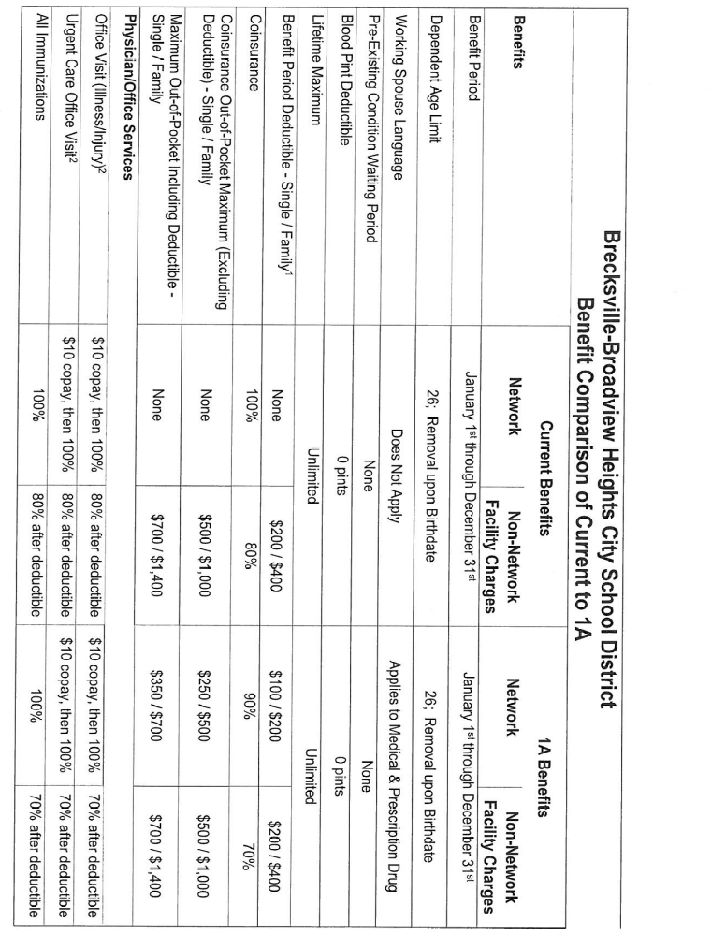
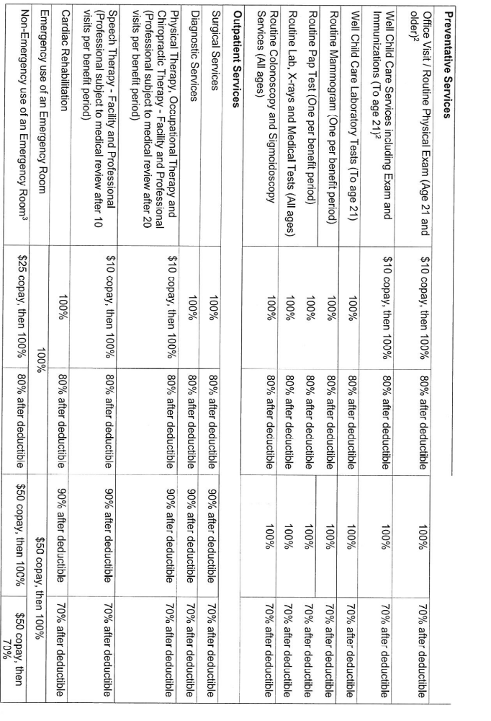
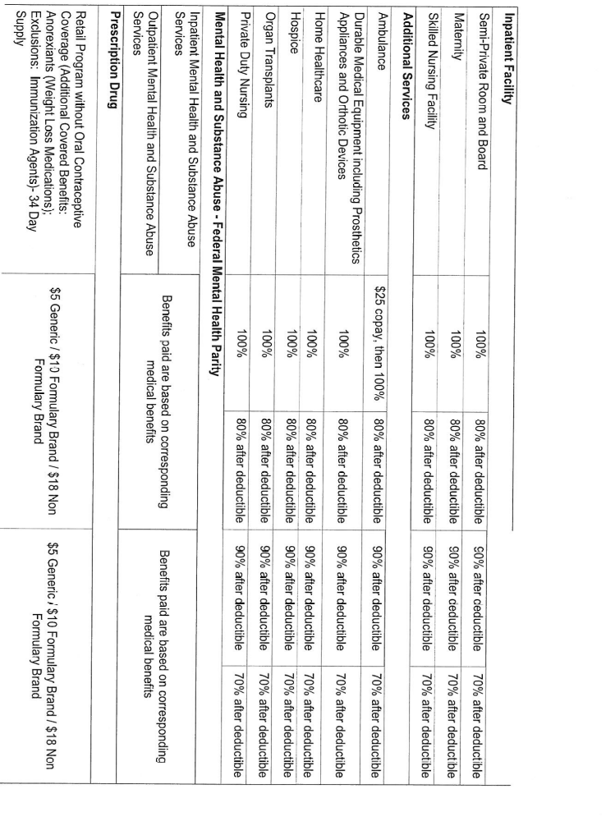
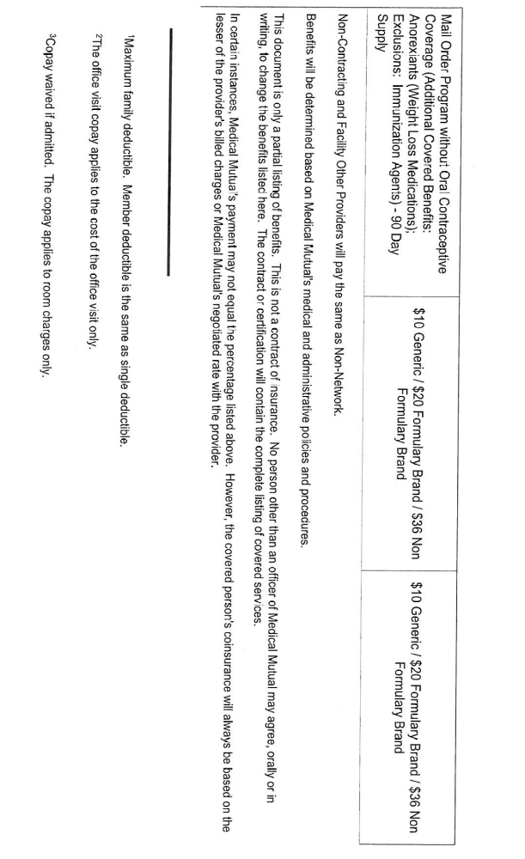
Suburban Health Consortium
Suggested Ideal Plan

 | Network | Non-Network
Calendar Year Deductible | $250/$500 | $500/$1,000
Coinsurance | 90% | 70%
Coinsurance Limit | $1,250/$2,500 | $2,500/$5,000
Out of Pocket Limit (Includes deductible) | $1,500/$3,000 | $3,000/$6,000
Inpatient Hospital
Inpatient Hospital | 90% after deductible | 70% after deductible
Surgery & Anesthesia | 90% after deductible | 70% after deductible
Physician Services | 90% after deductible | 70% after deductible
Supplies | 90% after deductible | 70% after deductible
Lab / X-ray | 90% after deductible | 70% after deductible
Outpatient Surgery
Outpatient Surgery | 90% after deductible | 70% after deductible
Maternity
Office Visits | $20 copay - first visit | 70% after deductible
Hospital Services | 90% after deductible | 70% after deductible
Prenatal-postpartum | 90% after deductible | 70% after deductible
Mental Health
Inpatient | 90% after deductible | 70% after deductible
Outpatient | 90% after deductible | 70% after deductible
ER/ Urgent care
Emergency Room (Emergency use) | $50 copay/90% | 70% after deductible
Urgent Care | $25 copay/90% | 70% after deductible
Medical Services
Office Visits | $20 copay | 70% after deductible
Routine Annual Exam | $20 copay | Not covered
Well Child Care | $20 copay | 70% after deductible
X-ray / Lab | 90% after deductible | 70% after deductible
Allergy Tests / Treatments | $20 copay | 70% after deductible
Other Services
Vision | $20 copay | Not covered
Skilled Care Facility | 90% after deductible | 70% after deductible
Home Health Care | 90% after deductible | 70% after deductible
Ambulance | $25 copay
Hospice Services | 90% after deductible | 70% after deductible
Durable Medical Equipment | 90% after deductible | 70% after deductible
Rehabilitative Services | 90% after deductible | 70% after deductible
Chiropractic Services | $20 copay | 70% after deductible
Prescription Drug Plan
Retail (30-day supply) | $10/$20/$40 | Not covered
Mail Order (90-day supply) | $25/$50/$100 | Not covered

Administrative Support Personnel Salary Schedule
2016-2017 |  | 1.50% | Increase
Step | Factor | Health Care Coord./ EMIS Coord. | Adm. Asst. Supt. | Asst. to Treasurer | Adm./Fiscal Assts.
0 | 1.00000 | 25.48 | 25.24 | 24.77 | 22.20
1 | 1.01000 | 25.73 | 25.50 | 25.01 | 22.42
2 | 1.02010 | 25.99 | 25.75 | 25.26 | 22.64
3 | 1.03030 | 26.25 | 26.01 | 25.52 | 22.87
4 | 1.04060 | 26.51 | 26.27 | 25.77 | 23.10
5 | 1.05101 | 26.78 | 26.53 | 26.03 | 23.33
6 | 1.06152 | 27.04 | 26.80 | 26.29 | 23.56
7 | 1.07214 | 27.31 | 27.06 | 26.55 | 23.80
8 | 1.08286 | 27.59 | 27.33 | 26.82 | 24.04
9 | 1.09369 | 27.86 | 27.61 | 27.09 | 24.28
10 | 1.10462 | 28.14 | 27.88 | 27.36 | 24.52
11 | 1.11567 | 28.42 | 28.16 | 27.63 | 24.77
12 | 1.12683 | 28.71 | 28.44 | 27.91 | 25.01
13 | 1.13809 | 28.99 | 28.73 | 28.19 | 25.26
14 | 1.14947 | 29.28 | 29.02 | 28.47 | 25.52
15 | 1.16097 | 29.58 | 29.31 | 28.75 | 25.77
Administrative Support Personnel Salary Schedule
2017-2018 |  | 1.50% | Increase
Step | Factor | Health Care Coord./ EMIS Coord. | Adm. Asst. Supt. | Asst. to Treasurer | Adm./Fiscal Assts.
0 | 1.00000 | 25.86 | 25.62 | 25.14 | 22.53
1 | 1.01000 | 26.12 | 25.88 | 25.39 | 22.76
2 | 1.02010 | 26.38 | 26.14 | 25.64 | 22.98
3 | 1.03030 | 26.64 | 26.40 | 25.90 | 23.21
4 | 1.04060 | 26.91 | 26.66 | 26.16 | 23.45
5 | 1.05101 | 27.18 | 26.93 | 26.42 | 23.68
6 | 1.06152 | 27.45 | 27.20 | 26.68 | 23.92
7 | 1.07214 | 27.72 | 27.47 | 26.95 | 24.16
8 | 1.08286 | 28.00 | 27.74 | 27.22 | 24.40
9 | 1.09369 | 28.28 | 28.02 | 27.49 | 24.64
10 | 1.10462 | 28.56 | 28.30 | 27.77 | 24.89
11 | 1.11567 | 28.85 | 28.59 | 28.05 | 25.14
12 | 1.12683 | 29.14 | 28.87 | 28.33 | 25.39
13 | 1.13809 | 29.43 | 29.16 | 28.61 | 25.64
14 | 1.14947 | 29.72 | 29.45 | 28.89 | 25.90
15 | 1.16097 | 30.02 | 29.75 | 29.18 | 26.16

